### Stepper motors

As stepper motors produce noise when rotating at different frequencies, the possibility of using them as an unconventional musical instrument was investigated. It was discovered that multiple videos of such an instrument were posted online such as those presented in [1] and [2] which confirmed that the instrument was feasible.

A stepper motor converts digital pulses into steps of a full rotation [3] and by varying the frequency of the pulses, the rotation of the shaft can be modified. The key difference between a stepper motor and a servo motor is that the stepper motor does not require a feedback mechanism since there is a direct relationship between a digital pulse and the amount by which the motor shaft rotates [4].

**Figure 2.X** Cross section of stepper motor [7]

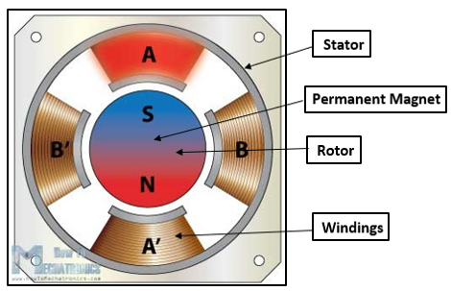

Figure 2.X illustrates the cross section of a stepper motor. It can be observed that the permanent magnet in the centre acts as the rotor of the motor and is surrounded by stator’s windings. To understand how the rotational movement is generated, the rotor and stator will be analysed separately. The rotor consists of two discs placed back to back: one of them acts as the north pole and the other acts as a south pole. The windings act as electromagnets that can be independently controlled and when a winding is activated, it attracts the disc of opposite polarity of the rotor. As the windings get activated in turns, this results in the rotational movement of the motor’s shaft being generated [5]

A stepper motor can be controlled in three different ways, depending on the precision that is required. These modes are full step, half step and microstep and the difference between them is represented by the order in which the windings are energised. For example, one digital pulse sent to a motor operating in half step mode produces an angular movement that is half of the one that is obtained by the same pulse when using a motor operating in full step mode.

The key aspect of stepper motors for them to be used as a musical instrument is represented by their ability to generate frequencies in the audible range (20 Hz – 20 KHz [6]) that correspond to musical notes. A song can be replicated by the stepper motors by sequentially generating the frequencies of the musical notes required and ensuring that they are generated for the correct amount of time.

# References

|  |  |
| --- | --- |
| [1] | MrSolidSnae745, “Toy Story - You've Got A Friend In Me {4 SM},” 26 April 2016. [Online]. Available: https://www.youtube.com/watch?v=RhyvsieEyas. [Accessed May 2018]. |
| [2] | 김진철, “Supermario theme Stepping motor,” 14 October 2014. [Online]. Available: https://www.youtube.com/watch?v=XYrb1ZV8E-U. [Accessed May 2018]. |
| [3] | O. Engineering, “What is a stepper motor? - Principles, types and controllers,” Omega, 2017. [Online]. Available: https://www.omega.co.uk/prodinfo/stepper_motors.html. [Accessed May 2018]. |
| [4] | “NEMA Stepper Motors & Controllers,” 2017. [Online]. Available: https://www.circuitspecialists.com/stepper-motor. [Accessed May 2018]. |
| [5] | C. Woodford, “How does a stepper motor work,” ExplainThatStuff, January 2018. [Online]. Available: http://www.explainthatstuff.com/how-stepper-motors-work.html. [Accessed May 2018]. |
| [6] | M. C. G. Y. N. K. K. Y. Leung, “Effect of ultrasound on acute inflammation of transected medial collateral ligaments,” *Archives of physical medicine and rehabilitation,* 2004. |
| [7] | D. Nedelkovski, “How a Stepper Motor Works,” HowToMechatronics, [Online]. Available: https://howtomechatronics.com/how-it-works/electrical-engineering/stepper-motor/. [Accessed May 2018]. |

NOTE: Reference 7 (audible range frequencies) has to be mateched with the one in technical work